**Coronavirus:**

**The world economy is now collapsing**

Martin Wolf

FINANCIAL TIMES

Published: Apr 16, 2020, 5:00 am SGT

How much worse it gets is yet unknown, but we do know what must be done to survive this terrifying upheaval with the least possible damage

In its latest *World Economic Outlook*, the International Monetary Fund (IMF) calls what is now happening, the "Great Lockdown". I prefer the "Great Shutdown": This phrase captures the reality that the global economy would be collapsing even if policymakers were not imposing lockdowns and might stay in collapse after lockdowns end.

Yet, whatever we call it, this is clear: It is much the biggest crisis the world has confronted since World War II and the biggest economic disaster since the Depression of the 1930s. The world has come into this moment with divisions among its great powers and incompetence at the highest levels of government of terrifying proportions. We will pass through this, but into what?

As recently as January, the IMF had no idea of what was about to hit, partly because Chinese officials had failed to inform one another, let alone the rest of the world. Now we are [in the middle of a pandemic](https://www.straitstimes.com/coronavirus" \t "_blank) with vast consequences. But much remains unclear. One important uncertainty is how myopic leaders will respond to this global threat.

For what any forecast is worth, the IMF now suggests that global output per head will contract by 4.2 per cent this year, vastly more than the 1.6 per cent recorded in 2009, during the global financial crisis. Ninety per cent of all countries will experience negative growth in real gross domestic product (GDP) per head this year, against 62 per cent in 2009, when China's robust expansion helped cushion the blow.

In January, the IMF forecast smooth growth this year. It now forecasts a plunge of 12 per cent between the last quarter of last year and the second quarter of this year in advanced economies and a fall of 5 per cent in emerging and developing countries.

But, optimistically, the second quarter is forecast to be the nadir. Thereafter, it expects a recovery, though output in advanced economies is forecast to remain below fourth-quarter 2019 levels until 2022.

This "baseline" assumes economic reopening in the second half of this year. If so, the IMF forecasts a 3 per cent global contraction this year, followed by a 5.8 per cent expansion next year. In advanced economies, the forecast is of a 6.1 per cent contraction this year, followed by a 4.5 per cent expansion next year. All this may prove too optimistic.

The IMF offers three sobering alternative scenarios. In the first, lockdowns last 50 per cent longer than in the baseline. In the second, there is a second wave of the virus next year. In the third, these elements are combined. With a second wave of infections, global output would be 5 per cent below the baseline next year. With both misfortunes, global output would be almost 8 per cent below the baseline next year.

Under the latter possibility, government spending in advanced economies would be 10 percentage points higher relative to GDP next year and government debt 20 percentage points higher in the medium term than in the already unfavourable baseline. We have no real idea which will prove most correct. It might be even worse: The virus might mutate; immunity for people who have had it might not last; and a vaccine might not be forthcoming. A microbe has overthrown all our arrogance.

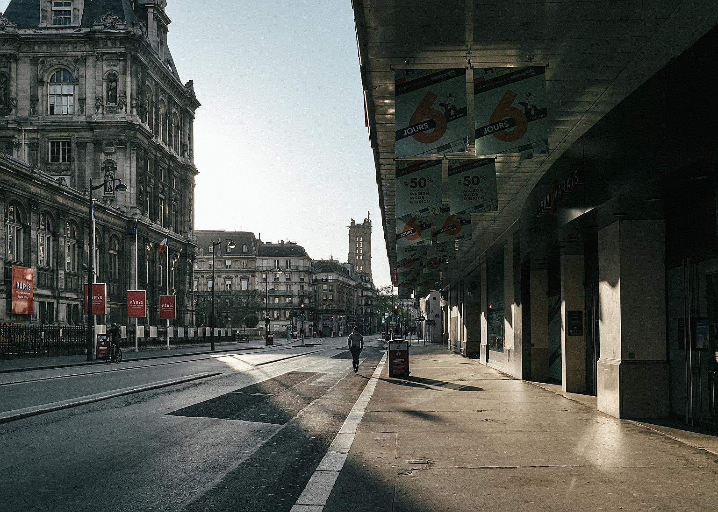An empty street in Paris on Monday. One answer is not to abandon the lockdowns before the death rate is brought under control, says the writer. It will be impossible to reopen economies with a raging epidemic, increasing numbers of dead and pushing health systems into collapse. PHOTO: NYTIMES

What must we do to manage this disaster?

One answer is not to abandon the lockdowns before the death rate is brought under control. It will be impossible to reopen economies with a raging epidemic, increasing numbers of dead and pushing health systems into collapse.

Even if we were allowed to buy or go back to work, many would not do so. But it is essential to prepare for that day, by creating vastly enhanced capacities to test, trace, quarantine and treat people. No expense must now be spared on this, or on investment in creating, producing and using a new vaccine.

Above all, as the introductory essay to a report from the Peterson Institute for International Economics in Washington on the essential role of the Group of 20 leading countries states: "Put simply, in the Covid-19 pandemic, lack of international cooperation will mean that more people will die."

This is true in health policy and in ensuring an effective global economic response. Both the pandemic and the Great Shutdown are global events. Help with the health response is essential, as Professor Maurice Obstfeld, former IMF chief economist, stresses in the report. Yet so too is economic help for poorer countries, via debt relief, grants and cheap loans. A huge new issue of the IMF's special drawing rights, with transfer of unneeded allocations to poorer countries, is needed.

The negative-sum economic nationalism that has driven Mr Donald Trump throughout his term as United States president, and has even emerged within the European Union, is a serious danger. We need trade to flow freely, especially (but not solely) in medical equipment and supplies. If the world economy is broken apart, as happened in response to the Depression, the recovery will be blighted, if not slain.

We do not know what the pandemic has in store or how the economy will respond. We do know what we must do to get through this terrifying upheaval with the least possible damage. We must bring the disease under control. We must invest massively in systems for managing it after current lockdowns end. We must spend whatever is needed to protect both our people and our economic potential from the consequences. We must help the billions of people who live in countries that cannot help themselves unaided.

We must remember above all that in a pandemic, no country is an island. We do not know the future. But we do know how we should try to shape it. Will we? That is the question. I greatly fear our answer.

APPENDIX:

Consider this Graph for unemployment in the U.S.A.:

